**Ancient Indian History - Gupta Period**

* North India came under the rule of several foreign people, such as the Yavanas, Kushans, Sakas, Parthians, etc. They began to settle in north-west India from the first century B.C. onwards.
* Foreign rulers came to India due to the turbulent condition in central Asia.They adjusted themselves with Indian culture, and introduced some new elements in India.
* Three big political powers emerged in India between the 1st century B.C. and 3rd century A.D., which played an important stabilising factor over large regions. They were −
  + Satavahanas in the Deccan,
  + Kushanas in the north, and
  + Sakas in the west.
* In the mid of 3rd century A.D., the empires of the Satavahanas and Kushanas came to an end.

**Gupta Dynasty**

* A new dynasty, known as Gupta, emerged in north India. They made a permanent impact on Indian history by building up a large empire. They have firmly established several trends of Indian culture like the Mauryas a few centuries earlier.
* Apart from political might and strength, the Gupta kings were also known for their great achievements in the field of science, art, culture, and literature.
* The Allahabad pillar inscription of Samudragupta mentions maharaja Srigupta and maharaja Ghatotkacha as his ancestors. But we do not know much about the early Guptas.
* I-tsing, a Chineses traveler, came to India between A.D. 671 and 695. He mentioned Srigupta as the builder of a temple at Gaya for the Chinese pilgrims about 500 years before his time.
* The king, Srigupta, has been identified as the first Gupta king mentioned in the Allahabad pillar inscription.
* Puranas also mentioned that the early Guptas controlled the area along the Ganga (the middle Gangetic basin), Prayag (Allahabad and surrounding region), Saketa (Ayodhya region), and Magadha.
* Ghatottotkacha succeeded his father Srigupta. He was also referred as the Maharaja in Gupta records.

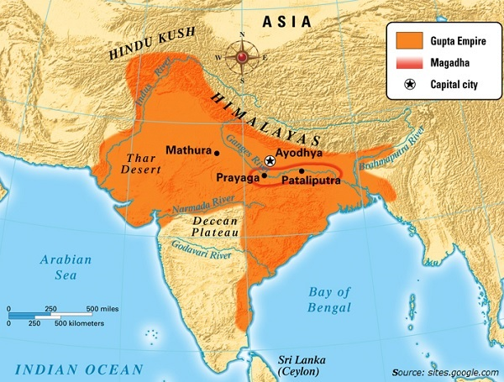

**Chandragupta-I**

* Chandragupta-I succeeded his father Ghatottotkacha in A.D. 320.
* Chandragupta-I was considered to have laid the foundation of the great Gupta Empire. He was married to a Lichchhavi princess Kumaradevi. The Lichchhavis were related to Gautama Buddh.

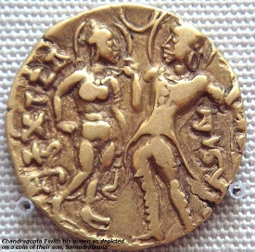

* The Lichchhavis were an old and established *Ganarajya* and quite powerful and still being respected in north India.
* The marriage alliance of Chandragupta-I was important for his political career as is proved by the coins Chandragupta I. These coins portray the figures of Chandragupta and Kumaradevi with the name of the Lichchhavis.
* In the Allahabad inscription, Samudragupta son of Chandragupta-I and Kumaradevi, proudly called himself Lichchhavis *‘Dauhitra’* i.e. son of the daughter of Lichchhavis.
* The Gupta era was started with a coronation of Chandragupta-I in A.D. 320. He was the first Gupta king to adopt the title *‘Maharajadhiraja’* and issued gold coins. Chandragupta-I introduced a new era called Gupta era.

**Samudragupta**

* Samudragupta succeeded his father Chandragupta-I about A.D. 340. He earned a reputation as one of the greatest kings and conquerors. He was chosen by his father as his successor because of his qualities that would make him into a good king.
* The Allahabad pillar inscription gives a detailed account of the career and personality of Samudragupta.
* Harishena one of the officials composed the inscription and engraved on the Ashoka's pillar at Allahabad.
* Samudragupta was a great military general. He had a long list of the kings and rulers whom he defeated and subdued as a part of his military achievements. He uprooted nine kings and princes from the Aryavarta and annexed their kingdom.
* Campaign of southern India was the most important campaign of Samudragupta
* Altogether twelve kings and princes of the south (*dakshinapatha*) are listed in the inscription.
* During the campaign of southern India, he adopted the policy of first capturing the kings, then releasing them from captivity, and then reinstalling them as kings in their territory. By showing royal mercy, he won their allegiance.
* Samudragupta proceeded for his south Indian campaign, through the eastern and southern parts of Madhyadesha to Orissa and then advanced along the eastern coast and reached Kanchi and beyond and returned to his capital by way of Maharashtra and Khandesh.
* Samudragupta performed ‘*Ashvamedhayajna*’ after his several conquests and issued gold coins depicting the sacrificial horse and bearing the legend, which conveying that he performed the *Ashvamedha* sacrifice.
* The Allahabad pillar inscription also lists fourteen kingdoms bordering his kingdom. These rulers paid tribute followed his orders and showed their obedience by attending his court.
* These were located in eastern Rajasthan, northern Madhya Pradesh, Assam, and Nepal. Further, some forest kings (atavika-rajas) are mentioned whom Samudragupta had made his ‘*Paricharaka*’ (helpers).
* Other political powers listed in the inscription are such as Kushanas, Sakas, Murundas as well as Simhalas (Sri Lanka) and inhabitants of other islands. These rulers sent embassies to Samudragupta's court.
* Meghavarna, the king of Sri Lanka, sent an embassy to Samudragupta for his permission to build a monastery and a guest house for Buddhist pilgrims at Bodh Gaya.
* Samudragupta was a versatile genius. He was called as ‘*Kaviraja*’ i.e. the king of poets. He was proficient in war and sastras as well.
* The Allahabad pillar inscription calls him a great musician. This is also confirmed by his lyricist type of coins, which shows him playing veena (lute).

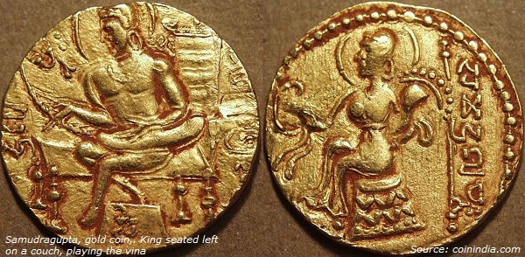

* Samudragupta patronized learned men in his court and appointed them as his ministers.
* Samudragupta died in about A.D. 380 and was succeeded by his son Chandragupta II.

**Chandragupta II**

* Chandragupta II was the son of Samudragupta and Dattadevi and he was chosen by his father as his successor.
* The Gupta Empire reached its highest glory, both in terms of territorial expansion and cultural excellence under Chandragupta II.
* Chandragupta II had inherited a strong and consolidated empire from his father Samudragupta.
* Chandragupta II had established a matrimonial alliance with Vakatakas by marrying his daughter Prabhavatigupta with Rudrasena-II of the Vakataka dynasty.
* Chandragupta-II made an alliance with the Vakatakas before attacking the Sakas so as to be sure of having a friendly power to back him up in Deccan.
* Prabhavatigupta acted as a regent on behalf of her two minor sons after the death of her husband Rudrasena II.
* Chandragupta-II’s victory over the mighty Sakas dynasty was his foremost success. The annexation of Sakas’s kingdom comprising Gujarat and part of Malwa strengthened the Gupta Empire, but also brought it into direct touch with western sea ports. This gave a great motivation to foreign trade and commerce.
* Ujjain, a major centre of trade, religion, and culture became the second capital of the Gupta Empire after the conquest.
* After the victory over Sakas, Chandragupta-II adopted the title of ***‘Vikramaditya.’***
* Chandragupta-II issued dated silver coins to commemorate his victory over Saka kshatrapas.

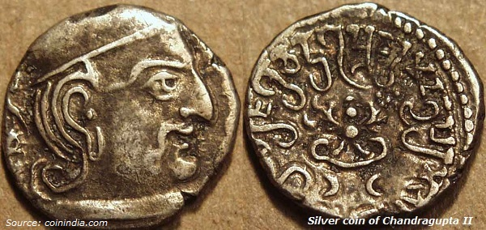

* The Mehrauli iron pillar inscription records portray a king named Chandra.
* The king Chandra is generally identified as Chandragupta-II. This would mean his kingdom extended from Bengal to the north-west frontiers.
* Chandragupta-II's reign is remembered for his patronage of literature and arts and for the high standard of artistic and cultural life.
* Kalidas, the great Sanskrit poet was a member of Chandragupta-II’s court.
* Fa-Hien, the Chinese Buddhist pilgrim visited India between A.D. 405 and A.D. 411. He visited for collecting Buddhist manuscripts and text and studying at Indian monasteries.

**Kumaragupta-I**

* Chandragupta-II died about A.D. 413. His son Kumaragupta became the next king.
* Kumaragupta ruled for more than forty years. He performed an *Ashvamedha* sacrifice; though his military achievements are not known.
* Kumaragupta issued *Ashvamedha* type of coins like his grandfather, Samudragupta.
* The epigraphic records show that he organised the administration of vast empire and maintained its peace, prosperity, and security for a long period of forty years.
* The Gupta Empire was challenged by the Pushyamitras at the end of Kumaragupta's reign.
* Pushyamitras were living on the banks of the Narmada.
* Skandagupta was the son of Kumaragupta-I.

**Skandagupta**

* Kumaragupta-I died in A.D. 455. His son Skandagupta became the next king.
* Skandagupta's reign seems to have been full of wars. He struggled with his brother Purugupta.
* Hunas were the greatest enemies of Gupta’s empire during this period.
* Hunas were a ferocious barbarian horde. They lived in central Asia.
* Skandagupta successfully defeated the Hunas. So they did not dare to disturb the Gupta Empire for half a century. Though they continue to disconcert Persia during this period.
* The important event of Skandagupta's reign was the restoration and repair of the dam on *Sudarsana* Lake after 8 hundred years of construction. It was built during Chandragupta Maurya's reign.
* *Sudarsana* Lake was also repaired previously during the reign of Saka kshatrapa Rudradaman I.
* The Gupta dynasty continued to be in existence for more than 100 years after the death of Skandagupta in A.D. 467.
* Skandagupta was succeeded by his brother Purugupta. Nothing is known about his achievements.
* **Budhagupta** was the only Gupta ruler who continued to rule over a large part of the empire.
* Budhagupta inscriptions have been found from Bengal, Bihar, Uttar Pradesh, and Madhya Pradesh.
* Huna’s leader, Toramana attacked Gupta Empire in A.D. 512. He conquered a large part of north India up to Gwalior and Malwa.
* Toramana was succeeded by his son Mihira kula. He founded his capital at Sakala (Sialkot).
* Huna ruled in India for a very short period, but the Gupta Empire suffered much from it.
* Huna rule was one of the shortest instances of foreign rule over India.
* Hiuen-Tsang describes that Mihirkula invaded Magadha. He was defeated and captured by the Gupta king Baladitya. It is also mentioned that Mihirkula’s life was saved at the intervention of the queen mother of Magadha.
* Inscription from Malwa mentioned that Yasovarman was a powerful local ruler of Malwa. He also defeated Mihirakula (Huna Ruler).
* During the period between Guptas and Harsha, polity, religion, society, economic life, literature, art, and architecture and technology were in the highest state of glory. Because of this reason, this period is popular as ‘a golden period’ of Indian history.

**Structure of Administration**

* Set up of the governments was well organized during the Gupta period, which provided a strong base for them to hold together their extensive territories for such a long period.
* In spite of intermittent wars among them, the reigns of the Guptas survived for two hundred years; the Chalukyas lasted for four hundred years; and Pallavas lasted for about six hundred years.
* The basic (governance) functionalities of the different dynasties were almost same except some differences in their name.
* The kingdom (*Rajya*) was divided into a number of provinces and they were known as ‘***Bhukti***’ in the north and ‘***Mandala***’ or ‘***Mandalam***’ in the south.
* The provinces were sub-divided as ‘***Vishaya’*** or ‘***Bhoga***’ in the north (India) and ‘***Kottams***’ or ‘***Valanadu***’ in the south (India).
* Some other units of administration were the districts, which were called as ‘***Adhis***,’ ‘***Thana***,’ or ‘***Pattana***’ in the north (India) and ‘***Nadu***’ in the south (India).
* The group of villages (i.e. modern tehsil) was known as ‘***Vithis***’ in the north (India) and ‘***Pattala***’ and ‘***Kurram***’ in the south (India).
* The villages were the lowest administrative units.
* There was a number of central, provincial, and local official to carry on the administration.

**Governance under Gupta Empire**

* The administration under Gupta Empire was largely dependent upon the old bureaucratic form of administration; however, they organized it much systematically and elaborately.
* The governor of ‘*Bhukti*’ was appointed by the king and known as ‘***Uparika***.’
* The administrative work was undertaken by a Board of Advisors, consisting of four members representing the various important sections, namely −
  + The ‘*Nagarsresthis*,’ were the chief of the guild of traders and bankers. They represented the guilds in particular and the urban population in general.
  + The ‘*Sarthavaha*,’ were the head of guild of traders and represented the various trading communities.
  + The ‘*Prathamakulika*’ (the chief of artisan) represented various artisan classes.
  + The ‘*Prathamakayastha*’ might have represented the government official like the Chief Secretary of the present day. This body was known as ‘*Adhisthanadhikarana*.’
* Each city administration had a council body.
* The village administration was under the control of rural bodies consisting of a headman and the village elders.
* During Gupta period, there was a remarkable growth of the local self-governing institutions such as the village committees and district committees.
* Inscriptions and literature records describe the existence of local bodies since very early period. They mentioned about the nature and the activities of these local bodies and testify to the most wonderful organization that the ancient Indians evolved.
* Two New classes of officers were introduced by the Guptas, namely −
  + ***Sandhivigrahika***, he was the minister of peace and war i.e. modern foreign minister
  + ***Kumaramatyas***, he was a body of top ranking officials attached not only to the king, but also to the crown-prince, and sometimes placed as in charge of districts.
* *Ayuktas* were another important official, they were same as *Yuktas* mentioned in the Ashokan inscriptions and in Kautilya's Arthasastra.
* During the Gupta period, many known officials - such as *Mahapratihara, Mahabaladhikrita,* and *Mahadandanayaka*, etc. used their title prefixed with ‘*Maha*.’ The powers of all these officials and officers emanated from the king.
* Gupta rulers assumed several titles such as ‘*Maharajadhiraja*,’ ‘*Parambhattaraka*,’ ‘*Parmesvara*,’ etc.
* In Allahabad pillar inscription, Samudragupta is described as equal to the Gods Indra, Varuna, Kuvera, and Varna and also as a ‘God dwelling on the earth’. Such titles were used by the rulers of foreign origin such as the Greeks, or the Kushanas, but never by a king of an Indian origin.
* Guptas were the first who adopted high sounding titles in the history of India.
* Literature of this period mentions the ideals of popular government.
* The Smritis explain that "the ruler has been made by Brahma, a servant of the people, getting his revenue as remuneration".
* During the Gupta’s period, the powers of the king were more restricted and he was advised to rule with the help of ministers and to respect the decision of guilds and corporate bodies.
* The Gupta kings are usually represented on their coins. They have been described as an excellent and unrivalled chariot warriors and horsemen.
* In the early history of India, Gupta period is considered as a landmark in the field of administration of law and justice. The legal literature, developed during this period, reflects a distinct advancement in the legal system.
* Lawmakers drew a clear line between civil and criminal law for the first time.
* The *Brihaspatismriti* enumerates eighteen titles of land and adds that fourteen of these have their origin in property (*Dhanamula*) and four in injury (*Himsamula*).
* During the Gupta period, the land became private property that could be sold for money.
* Detailed law about partition, sale, mortgage, and lease of land were mentioned in the law-books and in the inscriptions of this period.
* Kautilya’s Arthashastra enumerated a bigger list of taxes than those were found in the Gupta inscriptions.
* The burden of taxation was decreased in Gupta period because of the prosperity of the state.
* Land taxes were collected both in cash and kind. It was varying from one-fourth to one-sixth of the produce.
* Special officers are mentioned in the inscriptions to kept proper records of assessment and collection of revenues, land transactions, etc.
* Gupta period was considered as the golden phase of Indian literature.
* The wonderful literature was produced in prose, poetry, drama, and grammar. It is the noticeable product of the system of education and learning.
* The *Puranas* preserved the traditions, legends, moral codes, religious, and philosophical principles. They are eighteen in number.
* The *Smritis* are metrical texts containing the rules and regulations and laws for the guidance and governance of the society.
* *Smritis* are based on *dharmasutras* and *grihyasutras* of Vedic literature. They are written in verse.
* Some additions and alterations have been done to make *Smritis* suitable to the changing conditions of society.
* The commentaries on the *Smritis* were written after the Gupta period.
* The compilation of *Ramayana* and *Mahabharata* was completed by the 4th century A.D.
* Kalidas has written the best works in poetry, drama as well as in prose. His *kavyas* such as *Meghaduta, Raghuvamsa,* and *Kumarasambhava*, and dramas such as *Abhijnashakuntalam* are the best literary works of this time and it is considered as the best even today. These works have been translated into many languages.

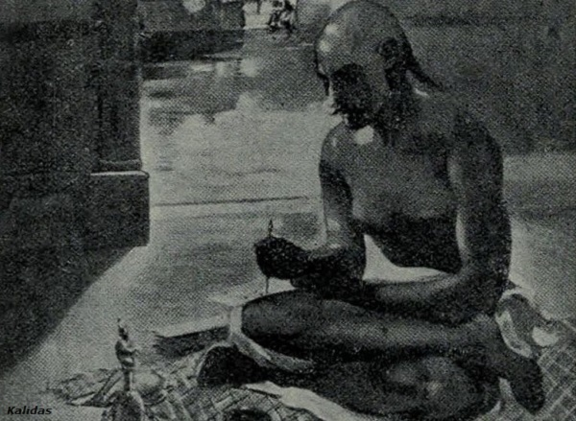

* Kalidas adorned the court of Chandragupta-II, the king of Ujjayini, who was popular as Vikramaditya.

**Inscriptions as Source**

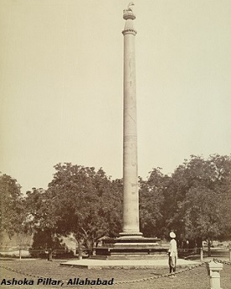

* A few inscriptions of the period are −
  + The Allahabad pillar inscription composed by Harisen;
  + Mandsor inscription composed by Vatsabhatt; and
  + Junagarh rock inscription, Mehrauli Pillar inscription, Aihole inscription composed by Ravikriti.
* These all inscriptions (listed above) consist most of the characteristics features of Sanskrit kavya.
* The most notable in the field of drama were Bhasa, Sudraka, Kalidas, and Bhavabhuti.
* *Mrichchakatika* (written by Sudraka), is considered one of the best plays of ancient India. This play is about the love of a Brahman with the beautiful daughter of a courtesan.
* Vishakhadatta had written two plays, namely *Mudrarakshasa* and *Devichandraguptam*.
* Famous plays written by Kalidas are *Malavikagnimitram, Abhijnanashakuntalam,* and *Vikramorvasiyam*.
* *Uttararama-charita* and *Malati-Madhava* were written by Bhavabhuti.
* *Panchatantra*, written by Vishnu Sharma, is one of the most famous works of this period. It was translated into Persian and Arabic in the 8th century A.D. and has been translated into almost all European languages by the time.
* The popular work *Hitopadesa* is based on the Panchatantra.
* *Harshacharita* is the biography of Harsha written by Banabhatta. It is an outstanding work of the period.
* The development of Sanskrit grammar (based on Panini and Patanjali) was also seen in this period.
* Bhartrihari composed three Shatakas. He had also written a commentary on the *Mahabhasya* of Patanjali.
* The compilation of the *Amarakosha* by Amarasimha is memorable work of this period. Amarasimha was a popular personality in the court of Chandragupta II.
* The Prakrit was popular language of the Gupta period (as it was earlier).
* The *Svetambara* Jain canon have been written in Ardha-Magadhi Prakrit.
* The religious texts of the *Digambara* Jain (of south India) were written in the *Maharashtri* and *Sauraseni* Prakrits.
* The commentaries on Buddhist texts were written in Pali.
* *‘Prakritaprakasha’* written by Vararuchi and *‘Prakritalakshana’* written by Chanda are the well-known grammar works on Prakrit and Pali language.
* ‘*Katyayanaprakarna*’ is a Pali grammar book.

**Foreign Accounts**

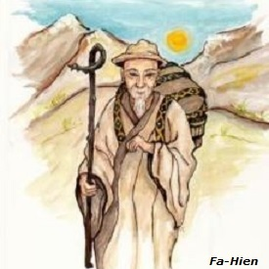

* **Fa-Hien**, the Chinese pilgrim with four other monks, came to India during the reign of Chandragupta II.
* Fa-Hien came to India through land route *via* central Asia and Kashmir and traveled across north India.
* Fa-Hien stayed three years at Patliputra and here he learned the Sanskrit language.
* Fa-Hien was interested only in Buddhism; however, he gave an idea of general peace and welfare during Gupta’s court.

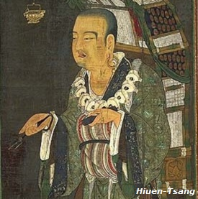

* **Hiuen-Tsang**, another Chinese traveler, visited India during Harsha's reign. He spent thirteen years in India, in which eight years, he stayed in Harsha's kingdom.
* Hiuen-Tsang had studied at Nalanda University. He visited various Indian kingdoms and mentioned about their condition. His book ***“Si-yu-ki”*** is a precious source of ancient Indian history.
* Hiuen-Tsang was honoured by Harshavardhana of Kanauj and Bhaskarvarma of Assam.

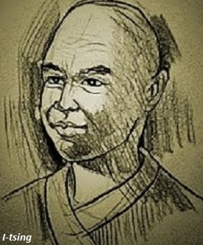

* **I-tsing**, a Chinese traveler, came to India *via* sea route. He spent many years in Sumatra and Sri Vijaya and learned Buddhism.
* I-tsing stayed at Nalanda for ten years and studied and translated Buddhist texts.
* I-tsing compiled a Sanskrit Chinese dictionary and translated a number of Sanskrit texts.
* I-tsing mentioned about Buddhist Religion as Practised in India. He gave a detailed account of Buddhism and general condition of India and Malaya.
* India had developed an advanced system of agriculture, industry, and trade long before the rise of the imperial Guptas.
* The economic stability and prosperity facilitates all-round cultural progress made during this period.
* The agriculture system was well developed and scientific methods were used to increase agricultural production.
* The *Amarakosha* and *Brihat Samhita* contain special chapters on the study of plants and gardens, forest, crops, manure, etc.
* Various branches of industry had developed because of the abundance of raw materials and the skill and enterprise of the artisans and the craftsmen.
* The literary works also describe a large variety of clothing such as cotton, silk, wool, and linen.
* Hiuen-Tsang described the classification of Indian clothing materials under the heads as - silk, cotton, linen, wool, and goat hair.
* *Amarakosha* mentions various terms used for the finer and coarser varieties of cloth as well as for unbleached and bleached silk.
* Ajanta wall paintings also exposed different techniques of weaving.
* The major centres of textiles production were Banaras, Mathura, Dashapura, and Kamarupa.
* The Mandsor inscription gives details about the guilds of silk weaver and corporate activities of the period.
* Ivory work flourished. A seal found in the excavation at Bhita reveals about the guilds of ivory workers.
* The leather industry also flourished. Leather boots and shoes were shown in the contempary sculptures and paintings.
* The art of the jewelery was in the advanced condition. The *Brihat Samhita* describes twenty-two jewels. Jewels were used at this period for a large variety of purposes.
* *Ratna pariksha* mentioned the science of testing gems. Technical sciences were utilised for the manufacture of metals.
* Vatsyayana mentions about *Ruparatnapariksha, Dhatuveda,* and *Maniragakarajnanam* i.e. testing of precious stones, the smelting of metals, and the technology of jewels accordingly.
* Hiuen-Tsang also mentioned that brass, gold, and silver were produced in abundance.
* The Mehrauli iron pillar (of Gupta period) is the best example of metal workmanships. The seals, gold, and silver coins of this period also reflect the advance stage of the metal industry.
* The ship building industry was also well developed in Gupta period that facilitated trade and communication activities.
* Smritis described in detail the laws of partnership, contract, right and duties of the individual members of the guild, and structure of guild that corroborated by contemporary literature and inscriptions.
* The seals and inscriptions mention about the legends *Sreshthi-kulika-nigama* and *Sreshthisarthavaha- kulika-nigama*. These permanent endowments reveal the function of the guilds in the capacity of banks as well as confirm their stable position in terms of business stability.
* Public works were undertaken and executed by the state as well as by the guilds.
* The repairs of *Sudarshana* lake dam and the connected irrigation canal in the province of Saurashtra were carried out by provincial governor Parnadatta and his son Chakrapalita during the rule of Skandagupta.

**Trade and commerce**

* Trade was carried on both through the land as well as the coastal routes.
* India had trade relations with both the eastern and the western countries.
* India maintained regular maritime relation with Sri Lanka, Persia, Arabia, Byzantine Empire, Africa, and even further west.
* India also developed commercial relations with China, Burma, and South East Asia.
* The important trade items were silk, spices of various kind, textiles, metals, ivory, sea produce, etc.
* Some important **sea ports** of the Gupta period were −
  + Tamralipti,
  + Arikamedu,
  + Kaveripattnam,
  + Barbaricum,
  + Muziris,
  + Pratishthana,
  + Sopara, and
  + Brighukachchha.
* All these ports (enumerated above) were well connected through inland routes from all parts of India.
* According to Fa-Hien, people of the 'Middle Kingdom' were prosperous and happy in the beginning of the 5th century and he also mentioned the similar account of prosperity and peace in India.
* People were maintaining a high standard of living and luxury of the town life.
* The land grants were given to Brahmans, temples, *viharas, mathas* to run the educational institutions and other social welfare activities.
* The tradition of land grants for the charitable purposes continued into the medieval period as well. These were known as *Madad-i-mash, Suyarghal*, etc.
* India had much advanced knowledge in the fields of mathematics, astronomy, and medicine during this period in comparison to any other country in the world.
* Arabs borrowed Indian knowledge of science and technology then it was taken by the western world from them.
* The mathematics and astronomy originated in Vedic period itself.
* **Aryabhata**, a great mathematics, wrote the book ‘***Aryabhatiya***’ in Kusumpura (Pataliputra) at the age of 23 years.

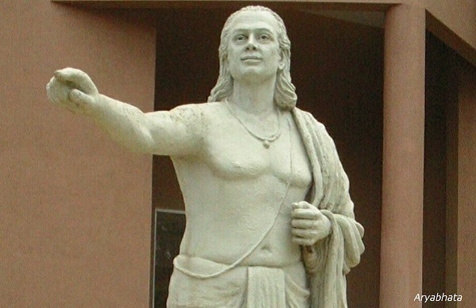

* *Aryabhatiya* is divided into four parts and the most important features of Aryabhata's mathematical system was the unique system of notation. It is based on the decimal place-value system unknown to other ancient people.
* Aryabhata explained various principals of geometry, an area of a triangle, the area of circle and the theorem relating to rectangles.

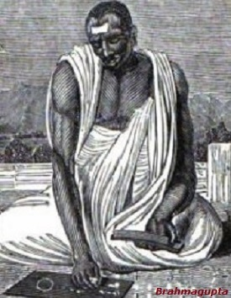

* **Brahmagupta** was also a famous mathematician. He wrote ‘*Brahmsiddhanta*’ in A.D. 628. He developed rules for operating with negative qualities and with zero. He began to apply Algebra to astronomical problems.
* ***Jyotisa*** was an ancient term used for astronomy and astrology. Varahamihira wrote ‘*Panchasiddhantika* in A.D. 505. He was á popular person in the court of Chandragupta II.
* *Panchasiddhantika* consisted five works (*siddhantas*), which is popular as *Paitamaha, Romaka, Paulisa, Vasishtha,* and *Surya*.
* The *Suryasiddhanta* is the most important and complete work on the astronomy of the period.
* Varahamihira wrote *Brihatsamhita*. This is considered as an encyclopedic work on astrology.
* Varahamihira's son, Prithuyashas also wrote a book on astronomy in about A.D. 600, named as *Harashatpanchashika*.

**Medicine**

* Ayurveda, literally means ‘science of longevity.’ This is the name of Indian medical sciences. It originated during the Vedic period.
* Vedic literature, particularly, Atharvanaveda consisted of more than seven hundred hymns on the topics related to Ayurveda.
* *Hastayurveda* is a guide book that describes (elaborately) the ‘animal diseases’ particularly about elephants.
* *Asvasastra* was written by sage Salihotra. It is a treatise on the horse.

**Metallurgy**

* Chemistry was another science that developed along with the medicine that helped in the development of metallurgy.
* Nagarjuna the great *Mahayanist* was also genus in chemistry.
* The Mehrauli iron pillar is a living memorial of this period. It portrays the progress in metallurgy achieved 1,500 years ago by the Indians. It has been surviving without rusting since its establishment (i.e. for over 1,500 years).

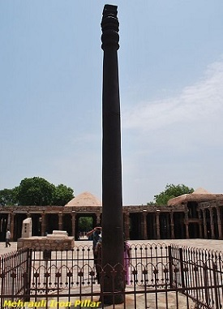

**Art and Architecture**

* The economic prosperity of the country during the Gupta period led to all round development in the field of sculptural art, architecture, and painting.
* In the Deccan, rock-cut caves were excavated. There are nine caves at Udaygiri near Vidisa. These are partly rock-cut and partly stone-built.
* Ajanta caves were built on the new line of architecture by the great beauty of their pillars of varied design and size and the fine paintings with which the inner wall and ceiling are decorated.
* Ellora’s rock-cut monasteries and chaitya halls are other piece of architecture. The Brahmanical, Buddhist, and Jain caves portray the final phase of development.

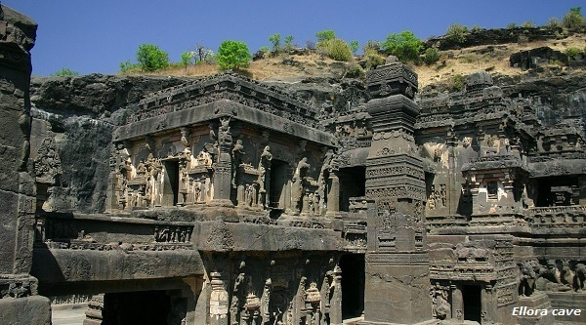

* Kailash temple is a magnificent monolithic temple with a spacious hall and finely carved pillars. It was carved into a block of hill.
* The seven monolithic temples and number of pillared halls at Mamallapuram were carved by the Pallava kings Mahendravarman and Narasimhavarman in the 7th century A.D.
* These monolithic temples were popularly called as ‘*Rathas*.’ These massive structural temples were completely cut out of rock.
* Monasteries and stupas were also built during this period. These Monasteries were also the centers of education.
* The famous centers were at Bodhgaya, Sarnatha, Kusinagara, Srayasti, Kanchi, and Nalanda.
* The Nalanda University grew into the most prestigious establishment during the 5th century A.D.
* Hiuen-Tsang mentioned in detail about the great temples, monasteries, and library buildings of Nalanda mahavihara.
* *Dharmarajaratha* at Mamallapuram is the earliest examples of the rock-cut temple of Dravidian styles.
* The structural temples at Kanchi, known as Kailasanatha and Vaikuntha Perumal were all built by the *Allava* Kings.

Sasanka:

* • About A.D. 525, one independent kingdom was established in Bengal.
* • Gauda kingdom comprises western and northern parts of Bengal. They declared their independence; however, the Maukharis defeated them.
* • **Sasanka** became the king of Gauda kingdom about half a century later. He founded his capital at Karnasuvarna (near Murshidabad). He occupied the whole of Bengal. He captured Orissa and then advanced towards Kanauj in the west against the Maukharis.
* • The Maukhari king Grahavarman was married to Rajyasri, daughter of Prabhakaravardhana. This marriage alliance strengthened the position of the two families.
* • Sasanka (Gauda), with the help of Malwa king, invaded Kanauj after the death of Prabhakaravardhana. The King Grahavarman of Kanauj, was killed and the queen Rajyasri was thrown into prison.
* • Hearing the news of Kanauj defeat, Rajyavardhana (brother of Harsha) started campaign to suppress the kings of Gauda and Malwa. But he was deceitfully killed by Sasanka.
* Rajyavardhana was killed by Gauda king Sasanka. **Harshavardhana** (younger brother of Rajyavardhana) was ascended the Pushyabhuti throne in A.D. 606 at the age of sixteen. He was also known as *‘Siladitya.’* He ruled for forty-one years.
* After Grahavarman's death, the Councilors of Maukhari state offered the throne to Harsha.